A000-Asia-China-Liangzhu Culture-Gong-Dragon-Alligator**-**Jade-3300-2250 BCE

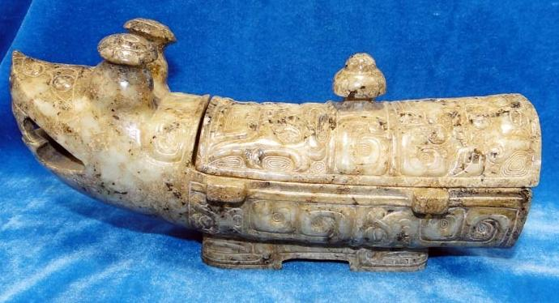

Fig. 1. China-Liangzhu Culture-Gong-Dragon-Alligator**-**Jade-3300-2250 BCE Atlantika Collection.

**Case no.: 5**

**Accession Number:**

**Formal Label:** China-Liangzhu Culture-Gong-Dragon-Alligator**-**Jade-3300-2250

**Display Description:**

This jade dragon gong came for a culture that has its origins in the Liangzhu site (3400–2250 BCE) in Yuhang County, Zhejiang. Liangzhu was a highly stratified Neolithic jade city-state in the Yangtze River delta where élites controlled a sphere of influence north to Shanxi and south to Guangdong. DNA recovered from Liangzhu graves shows high frequencies of Haplogroup O1 linking it with modern Austronesians. The use of jade and other expensive wares (such as silk, lacquerware, and ivory) in Liangzhu grave sites characterized the social symbolism of Liangzhu élites. About 4200 BP Liangzhu succumbed to a series extreme floods since the cultural layers are interrupted by intrusions of mud and sand. It is also possible that an asteroid created Taihu lake 4500 BP, which contributed to its demise.

This Liangzhu jade *gong* depicts an alligator (*Alligator sinensis*) with an iconography incorporating muntjak deer antlers, taotie images of apotropaic animal protectors, and "hooked cloud" motifs and fire symbols on its antlers. *Alligator sinensis*. had emigrated west via the Bering land bridge during one of the glacial maxima and had settled in southern China. It was an isolated species that had crocodile cousins in the verdant swamps of Vietnam and Cambodia. This Chinese alligator although diminutive in size when compared with its New World relative captured the imagination of expert jade sculptors.

The reason for this fascination with the Chinese dragon- alligator was that in Neolithic China there was a belief that the appearance of dragons brings about rain. Was there any truth to this belief? It was certainly a question that was being asked in the Confucian era when the rationalist critic Wang Ch'ung (27 Common Era = AD hereinafter CE to ca. 100 CE) acceded to the existence of unexplained phenomena in the Lun-heng (論衡, "Discourse balance" ca. 80 CE, a compilation of critical essays on natural science, Chinese mythology, philosophy, and literature. So it may be affirmed that by this date the dragon principle was rationally accepted as verified by the latest scientific methods available.

When reference is made to the alligator in Chinese sources, the reference is to the one genus of Chinese **Crocodilia**, *Alligator sinensis* (揚子鱷, yáng zǐ è) and not to the crocodile, (subfamily **Crocodylinae**) or **true crocodiles**, large aquatic tetrapods that live throughout the tropics in Africa, Asia (exclusive of China), the Americas and Australia. The **Crocodilia** (or **Crocodylia**) is the Latin order of large, predatory, semi-aquatic reptiles that appeared 83.5 million years ago in the Late Cretaceous period. Crocodilia are the closest living relatives of birds and both are the only known survivors of the **Archosauria, that also i**ncludes all extinct dinosaurs, extinct crocodilian relatives, and pterosaurs. There have been no true crocodiles in China.

*Alligator sinensis* is one of only two known living species of *Alligator*, which is now native only to the lower reaches of the Yangtze River, along Yijiang and Taihu river-basin swamps and in the provinces of Jiangsu, Zhejiang, and Anhui. However, in the past its range was throughout most of southern China.

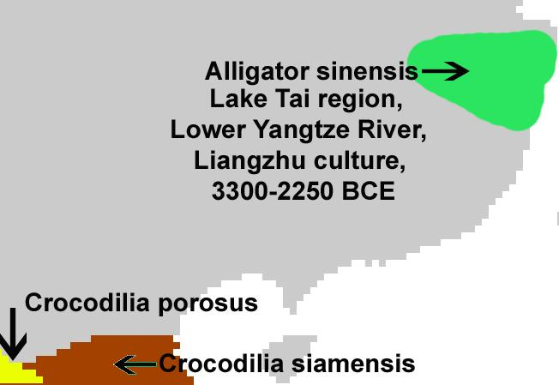

Range of *Alligator sinensis* coinciding with the jade-working, Neolithic, Liangzhu Culture, ca. 3300-2250 BCE.

Unlike its cousin, the American alligator, the Chinese alligator is armored over its entire body a feature of only a few Crocodilia, the order of large reptiles dating back 83.5 million years and named for the so called "pebble-worm" (κροκόδειλος Greek) texture of its body scales, which resembles the later Chinese Bronze Age Shang moiré pattern of curvilinear spirals that fills the interstitial surfaces on ritual bronze vessels. Hence we may infer that the Shang use of this artistic motif is related to *Alligator sinensis* as the archetypal embodiment of the Chinese concept of dragon, as most of the Shang bronze animal containers representative of mythical animals and dragons have this imagery emblazoned over their bodies.

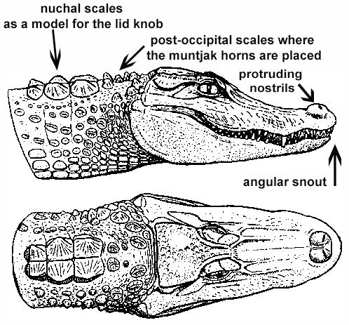

*Alligator sinensis* after Wermuth & Fuchs (1978)

In fact, this was from a biological and ecological point-of-view entirely reasonable. The Chinese alligators appeared when the monsoonal rains first inundated the patties: this was the harbinger of rice fructification, as the alligators scrambled up the slopes to secure a nesting site to lay their eggs that required access to at least 5 hours of sunlight each day as the females do not incubate their young.

**The Monsoon as the Dragon's Time**

The monsoon is a seasonal reversal of air currents accompanied by corresponding changes in precipitation (Ramage 1971). This is a seasonal change in atmospheric circulation and precipitation associated with the asymmetric heating of land and sea (Trenberth, Stepaniak, Caron 2000). Traditionally, "monsoon" refers to the rainy phase of a seasonally-changing pattern of which its alternative is a dry phase. Over oceans, the air temperature remains relatively stable for two reasons: because water has a relatively high specific heat (3.9 to 4.19 J g−1 K−1) (<http://www.engineeringtoolbox.com/specific-heat-fluids-d_151.html>), and because both conduction and convection will equilibrate a hot or cold surface with deeper water (up to 50 m.). In contrast, dirt, sand, and rocks have a lower specific heat (0.19 to 0.35 J g−1 K−1) (<http://www.engineeringtoolbox.com/specific-heat-solids-d_154.html>), which can only transmit heat into the earth by conduction and not by convection. Therefore, bodies of water stay at a more even temperature, while land temperature is more variable.

During warmer months sunlight heats the surfaces of both land and oceans, but land temperatures rise more quickly because it has a lower specific heat. As the land's surface becomes warmer, the air above it expands and an area of low pressure develops. Meanwhile, the ocean water which has a higher specific heat remains at a lower temperature than the land, and the air above it retains a higher pressure. This difference in pressure (lower over land and higher over water) causes sea breezes to flow from the ocean to the land, bringing moist air inland. This moist air rises to a higher altitude over land and then it flows back toward the ocean (thus completing the cycle). However, when the air rises, and while it is still over the land, the air cools with the higher elevation it attains. This decreases the air's ability to hold water, and this causes precipitation over the land. This is why summer monsoons cause so much rain over land.

A unique depiction of a late Neolithic jade alligator from the Liangzhu Culture (3300-2250 BCE) has been discovered recently that portrays the denizen of the watery deep in white jade. This jade alligator has motifs carved on its surface that relate to both the heavens (cloud motifs) and to water (reptilian motifs, perhaps alligators) and curvilinear moiré spirals. The coincidence of this imagery of heavens and water suggests the ecological demands of Neolithic agriculture in China: the need for water as predicted from the seasonal monsoonal season when the rains would ensue to ensure a productive harvest.

It is provocative that the moiré pattern of curvilinear spirals on Neolithic jade cloud motifs and on Shang Dynasty bronze vessels have this image of a cyclic pattern associated with the heavens.

A description of an entire ritual to invoke rain is included in the Ch'un-ch'iu fan-lu by Tung Chung-shu. It was in this ritual that a unique jade alligator like this one held a prominent place for the alligator was the repository of the sacred libation that could invoke the dragon spirit and usher in the monsoonal rains.

**LC Classification:** NK5750.2.A1

**Date or Time Horizon:** Liangzhu culture, 3300-2250 BCE

**Geographical Area:** Liangzhu culture, lower Yangzi River Valley

**Map:**

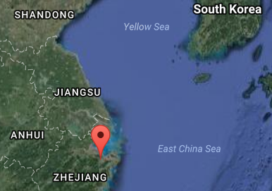

Source: Google Earth

**GPS coordinates:**

Northeast corner: N 30°24'48", E 120°00'17"

Northwest corner: N 30°24'41", E 119°58'58"

Southeast corner: N 30°23'20", E 120 00'19"

Southwest corner: N 30°22'55", E 119°58'28"

**Cultural Affiliation:** Liangzhu culture, lower Yangzi River Valley, 3300-2250 BCE

**Medium:** Jade

**Dimensions:**

**Weight:**

**Condition: original**

**Provenance:**

**Discussion:** from an old Chinese collection

Gongs/ kung1 ([觥](http://en.wiktionary.org/wiki/%E8%A7%A5)) are wine pitchers, used in the Shang and Zhou dynasties ca. 1700 to 900 BCE in shamanic rituals. Shamans (Wu巫) in Chinese spirituality could be both men and women, In the oracle bone script the pictograph was written



KangXi: [page 325](http://www.kangxizidian.com/kangxi/0325.gif), character 19 from http://www.kangxizidian.com/kangxi/0325.gif

In this ritual the participants would enter ecstatic trances and visit the places the animals depicted on these vessels were thought to inhabit, usually inaccessible high mountain or underwater retreats. The origin of the term comes from the oracle bone script:



KangXi: [page 1142](http://www.kangxizidian.com/kangxi/1142.gif) from http://www.kangxizidian.com/kangxi/1142.gif.

The ritual bronze vessels usually have a vertical handle often in the shape of the neck and head of an animal with stylized horns, and the spout of the vessel is in the form of the head of a creature whose mouth constitutes the end of the spout. They are decorated with taotie饕餮 designs in the form of frontal, bilaterally symmetrical, zoomorphic masks with raised eyes and no lower jaw.

The taotie design has been traced to the Liangzhu culture (3310–2250 BCE), the last Neolithic jade culture in the Yangtze River Delta, that produced large ritual jades, incised with the taotie motif. Its area of influence extended from around Lake Tai north to Nanjing, east to Shanghai and south to Hangzhou.

The two theories of the origin and meaning of taotie motifs are that the ancient face masks encompass the personae of either 1) shamans or 2) the god-kings. If the former interpretation is held they may represent faces of animals used in the sacrificial ceremonies. If the latter interpretation is held the faces were those of the god-kings who were the link between humankind and their deceased ancestors (Jordan Paper). When the taotie design is incorporated into the it appears to confirm to the first interpretation, as the wine that was placed in these vessels could be construed as the sacrificial blood of the (mythic) animal(s) depicted that was to render the spirit of the animal's vitality in those who imbibed its "blood". In the latter interpretation the imbibing of the sacrificial blood was that of the god-king with whom the participant would then enter into union.

Imbibing of sacrificial blood to attain union with the sacrificed one is an ancient theme that was incorporated into Dionysian libations and into the Christian Eucharist and retains distinct shamanic and later Gnostic overtones of attaining spiritual union with the spiritual mediator between heaven and earth.

**References:**

Chang, K.C., Xu, P. and Lu, L. 2005. *The formation of Chinese civilization: an archaeological perspective*. New Haven: Yale University Press.

Frazer, James George. 1911.The Magic Art and the Evolution of Kings, The Golden Bough, v. 2. London: Macmillan.

Li, Hui; Huang, Ying; Mustavich, Laura F.; Zhang, Fan; Tan, Jing-Ze; Wang, ling-E; Qian, Ji; Gao, Meng-He; Jin, Li. 2007. "Y chromosomes of prehistoric people along the Yangtze River," Human Genetics **122**: 383–388.

Wu, Li. 2014. "Holocene environmental change and its impacts on human settlement in the Shanghai Area, East China," Catena. **114**: 78–89

Zhang, Chia; Hsiao-Chun, Hung. 2008. "The Neolithic of Southern China–Origin, Development, and Dispersal,"Asian Perspectives. **47**:2, 309–310.

Zhou Ying. 2007. "The Dawn of the Oriental Civilization: Liangzhu site and Liangzhu culture. Beijing: China Intercontinental Press.